**Systems Programming**

**Project Report**



*Can Şirin 041401014*

*Selin Ersev 041401028*

**SELİN ERSEV**

**SCRIPT SIMPLE:**

**html-tag-shower.sh ->** This script shows html code with line number and colors line do start with ‘<’ and ends with ‘>’

**Argument ->** Takes .txt file

**SCRIPT MEDIUM:**

**install-with-pip.sh ->** This script installs python’s pip then create requirements.txt, and upgrades python libraries

**SCRIPT COMPLEX:**

**take-shuttle-hours.sh ->** This script takes shuttle ours from website

**SCRIPT EASY:**

**newSyntaxSelin.sh ->** This script changes “chmod” as a “permission”

**CAN ŞİRİN**

**SCRIPT SIMPLE:**

**generate-password.sh ->** This script generates random n-password according to argument

**Argument ->** Takes n

**SCRIPT MEDIUM:**

**send-email.sh ->** This script sends email

**Argument ->** Takes .txt file

**SCRIPT COMPLEX:**

**install-dotfiles.sh ->** This script installs personal dotfiles

**SCRIPT EASY:**

**newSyntaxCan.sh ->** This script changes “cd ..” as a “..”

**NEW SYNTAX**

***Selin Ersev***

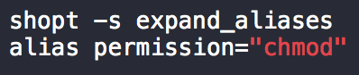

***Can Şirin***

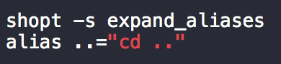

**PROGRAM OUTPUTS**

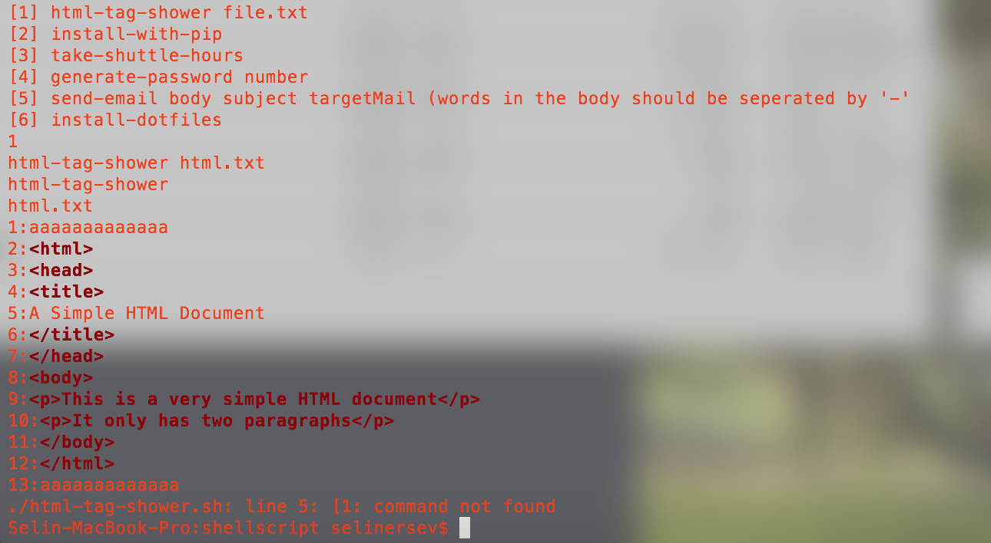

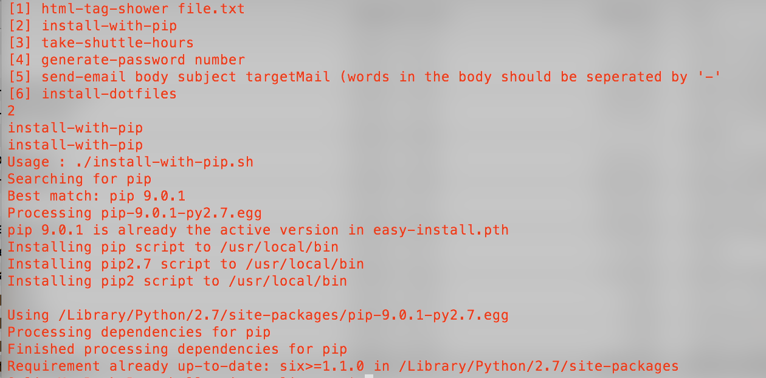

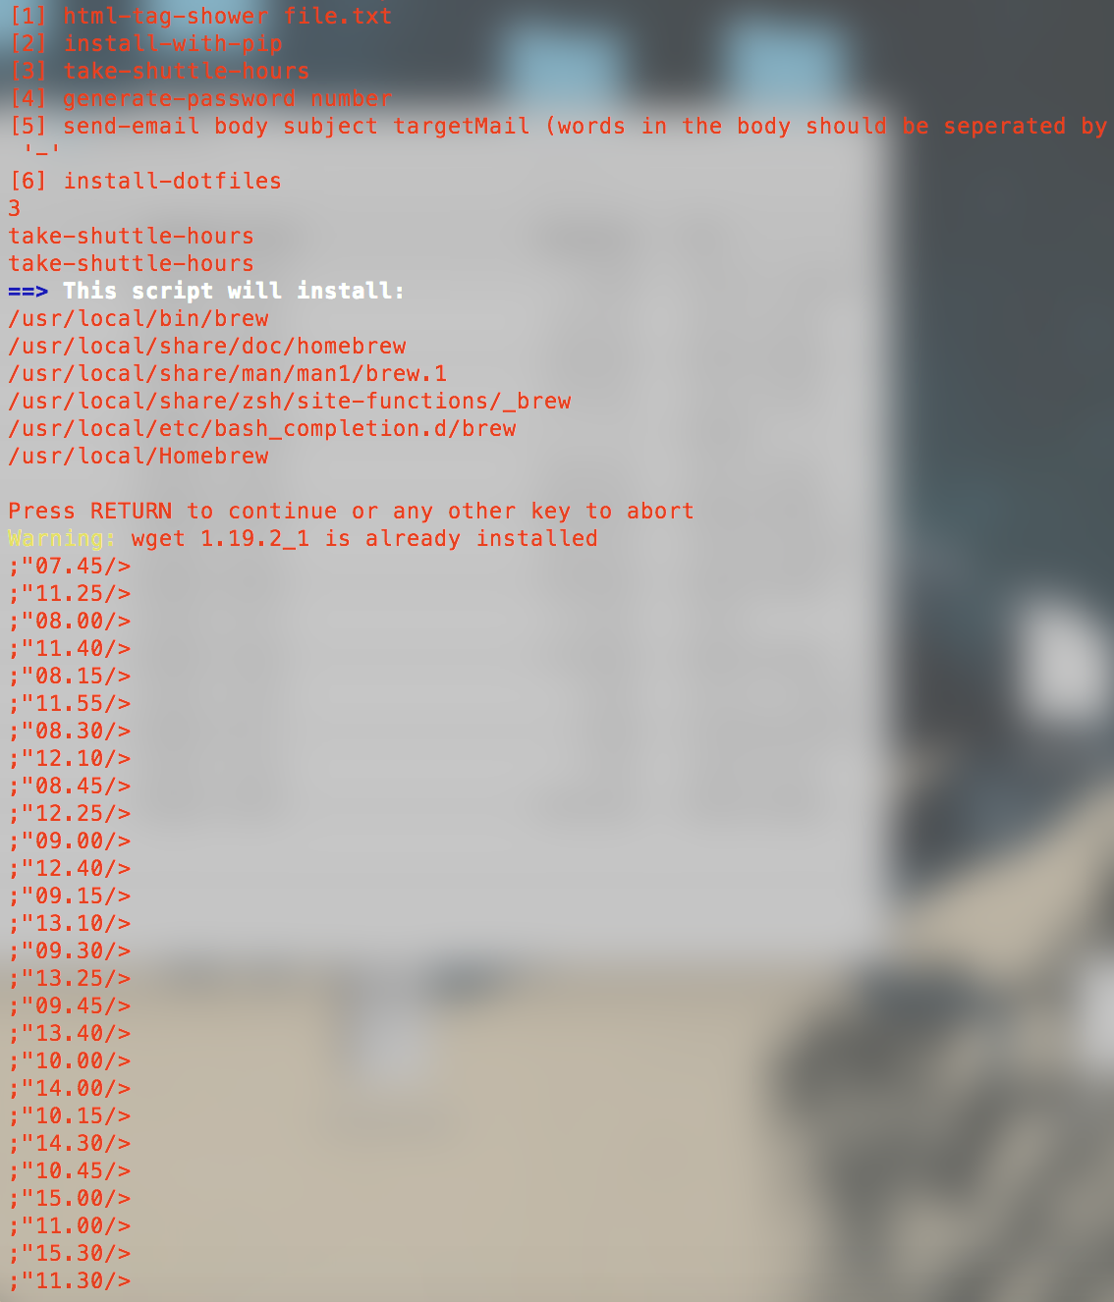

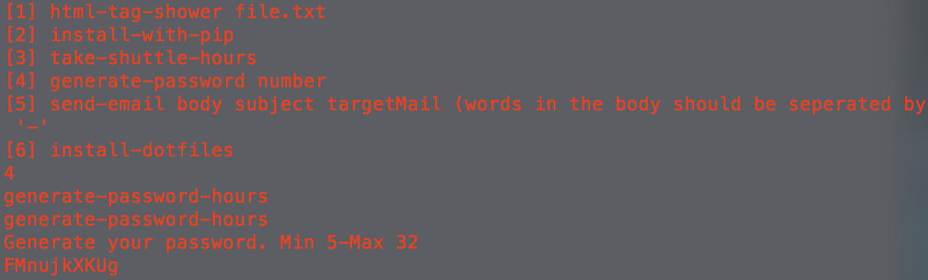

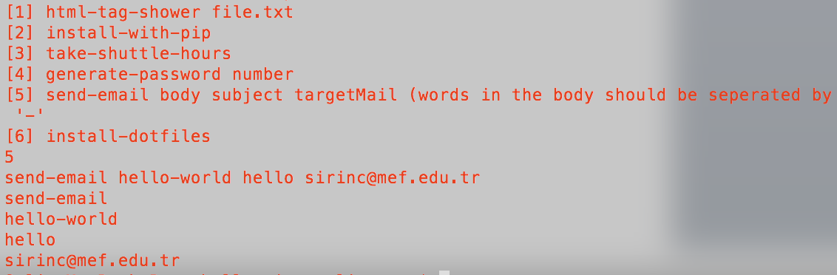

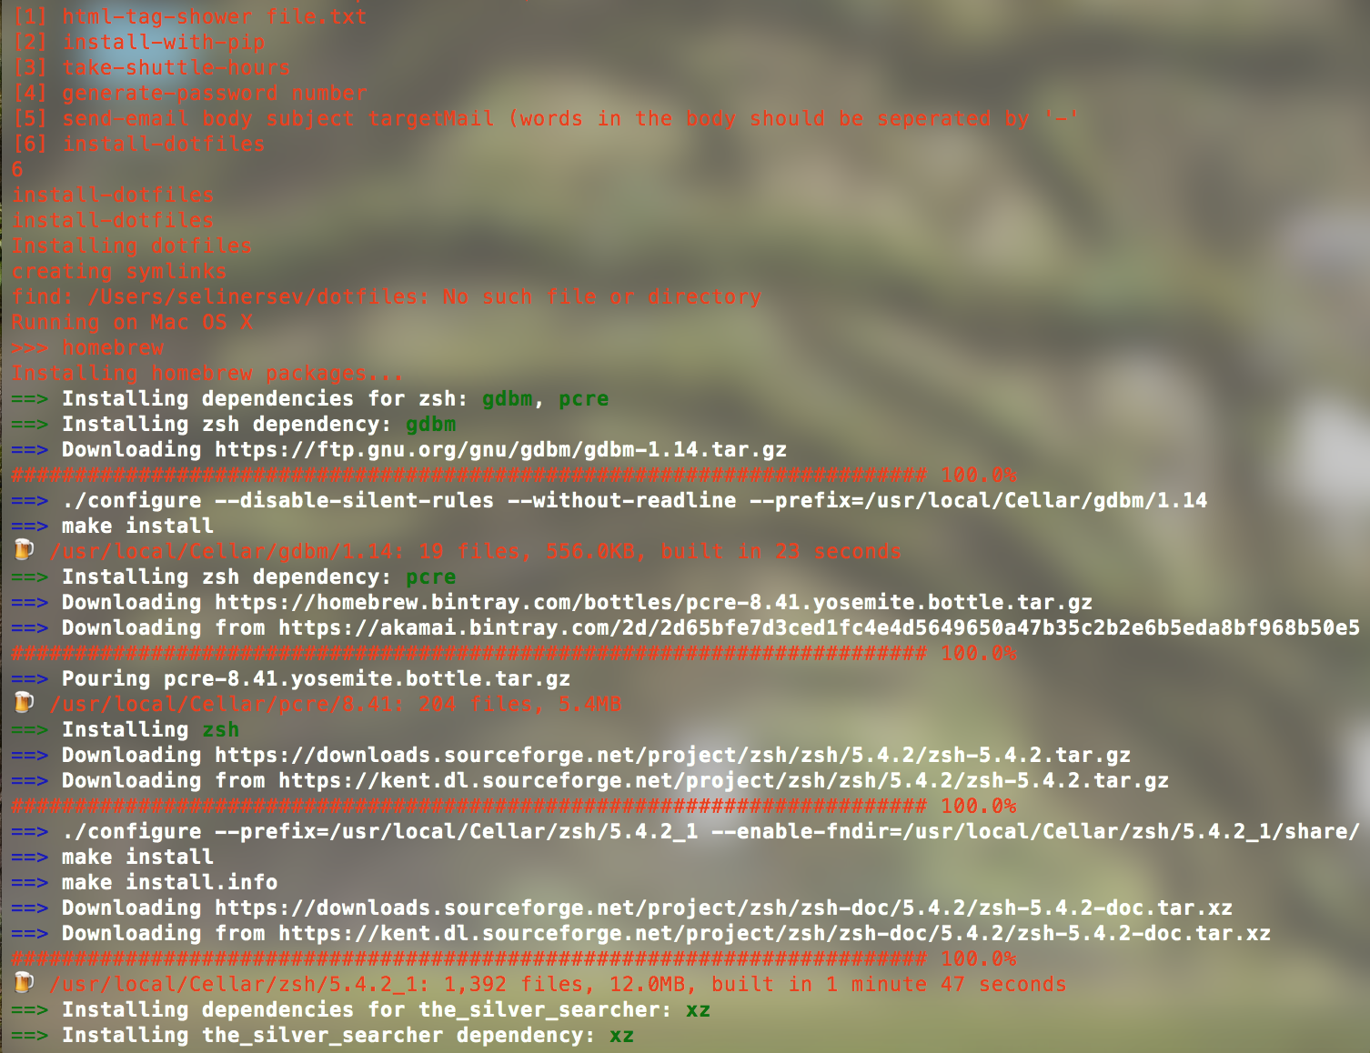

**GitHub Links**